LAPORAN PRAKTIKUM

Algoritma Pemrograman

MODUL 5 & 6

FOR-LOOP



Disusun oleh:

Cofa Xavier Marvel 109082500001

S1IF-13-04

PROGRAM STUDI S1 INFORMATIKA

FAKULTAS INFORMATIKA

TELKOM UNIVERSITY PURWOKERTO

2025

1. Guided 1

Source Code

|  |
| --- |
| package main  import "fmt"  func main() {      var j, h, k float32      fmt.Scan(&h, &k)      for j = h; j >= k; j -= 1 {          fmt.Print(j, " ")      }  } |

Screenshoot program

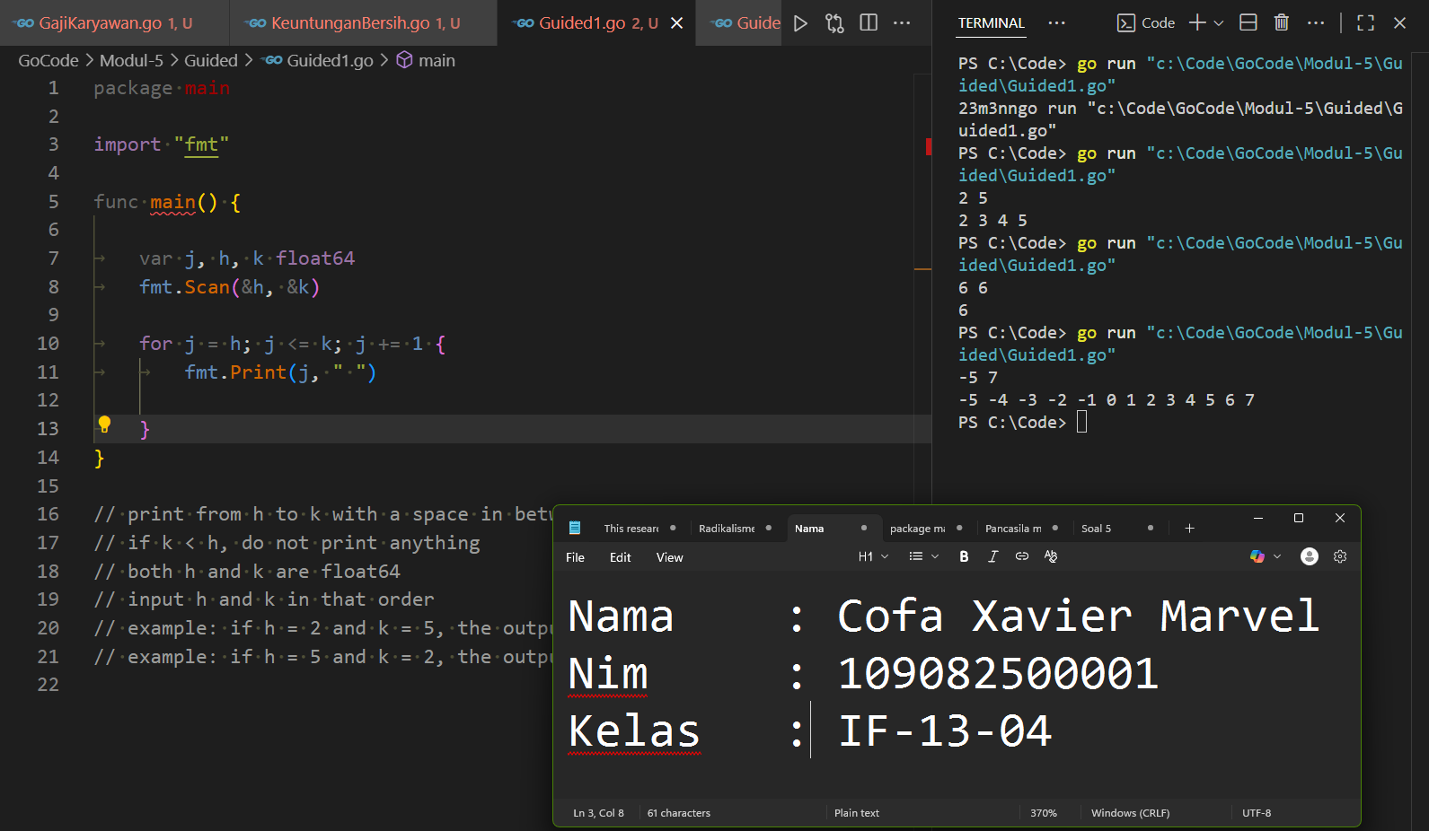

Deskripsi program

This program uses a for loop to increase the first number given till it is equal to the second number and printing all the increments.

2. Guided 2

Source Code

|  |
| --- |
| package main  import "fmt"  func main() {      var base, height, n, h int      var area float64      fmt.Scan(&n)      for j := h; j < n; j += 1 {          fmt.Scan(&base, &height)          area = 0.5 * float64(base*height)          fmt.Printf("Area : %.2f", area)      }  } |

Screenshoot program

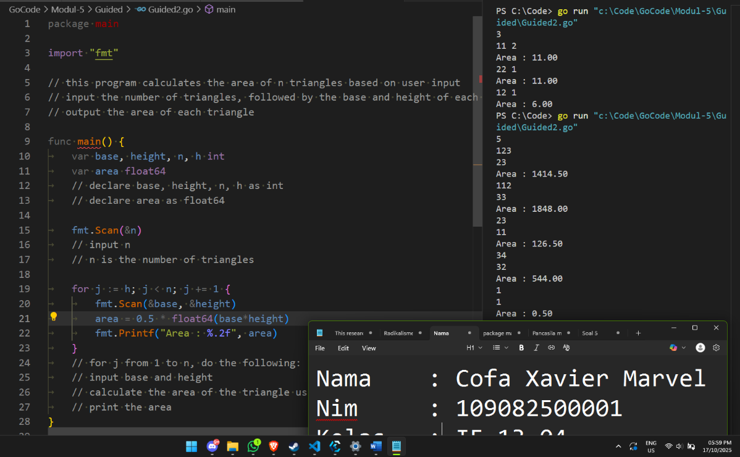

Deskripsi program

This program takes the first input as n which is the number of triangles the program will calculate the next two number are the base and the height in that order, after it will out put the area of the triangle then scan for another two inputs and calculates again until j equal to n.

3. Guided 3

Source Code

package main

import "fmt"

func main() {

    var j, v1, v2, result int

    // declare j, v1, v2, result as int

    fmt.Scan(&v1, &v2)

    // input v1 and v2 in that order

    result = 0

    // initialize result to 0

    for j = 1; j <= v2; j += 1 {

        result = result + v1

    }

    // for j from 1 to v2, do the following:

    // add v1 to result

    // increment j by 1

    fmt.Println(result)

    // print result

}

Screenshoot program

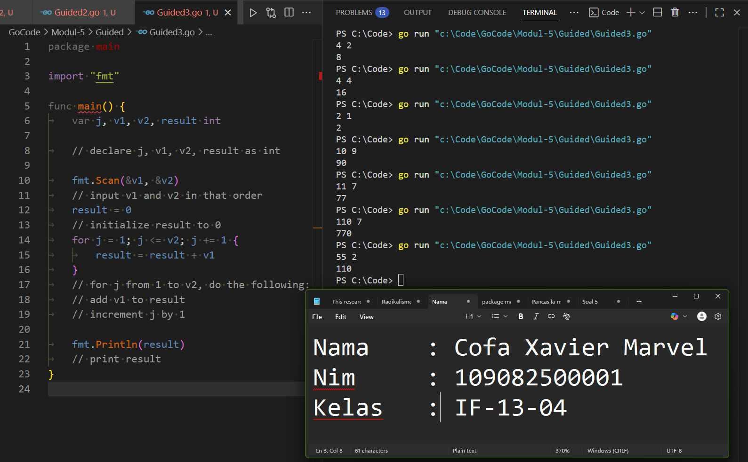

Deskripsi program

This program will increase the first number by itself by the second number functionally a times.

TUGAS

Tugas 1

Source code

|  |  |  |
| --- | --- | --- |
|  | package main  import "fmt"  func main() {      var m, n int      // declare m and n as int      fmt.Scan(&n)      // input n      for i := 0; i <= n; i++ {          m = m + i      }      // for i from 0 to n, do the following:      // add i to m      // increment i by 1      fmt.Print(m)  } |  |
|  |

Screenshoot program

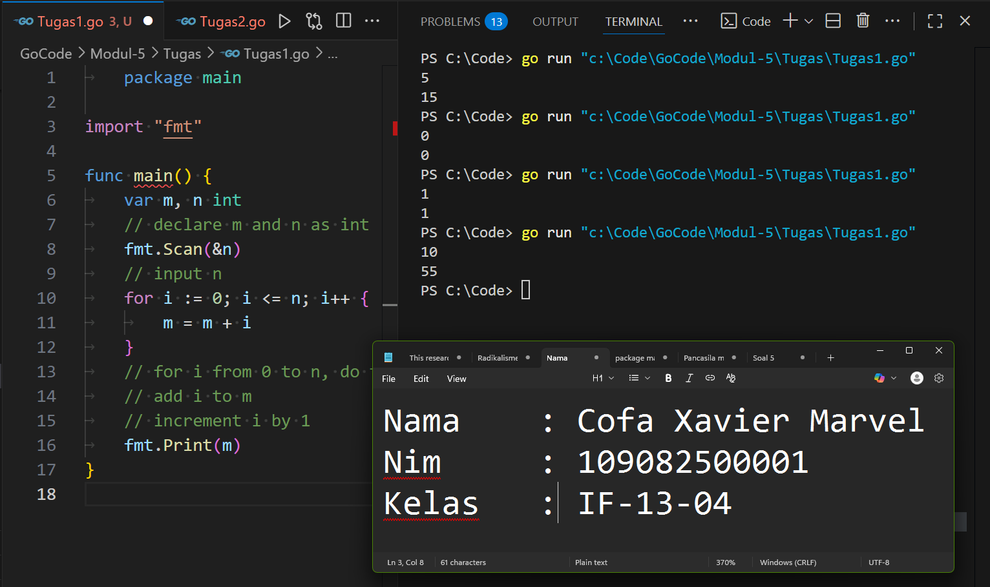

Deskripsi program

Given number: n

Sum of all positive numbers smaller than and equal to n: m

the initializer of the for loop: I

This program sums all the positive numbers from 1 to n using a for loop.

I is increased by one for each loop that does fulfil the proposition I <= n whilst increasing m by I. It does this until I is equal to n which then it will print m.

Tugas 2

Source code

|  |  |  |
| --- | --- | --- |
|  | package main  import (      "fmt"      "math"  )  func main() {      var n, radius, height int      // declare n, a, b as int      fmt.Scan(&n)      // input n      for i := 1; i <= n; i++ {          fmt.Scan(&radius, &height)          volume := math.Pi * math.Pow(float64(radius), 2) * (float64(height) / 3)          fmt.Printf("Volume : %.14f\n", volume)      }      // for i from 1 to n, do the following:      // input a and b      // calculate the volume of the cylinder using the formula π * r^2 * h/3      // print the volume with 14 decimal places  } |  |
|  |

Screenshoot program

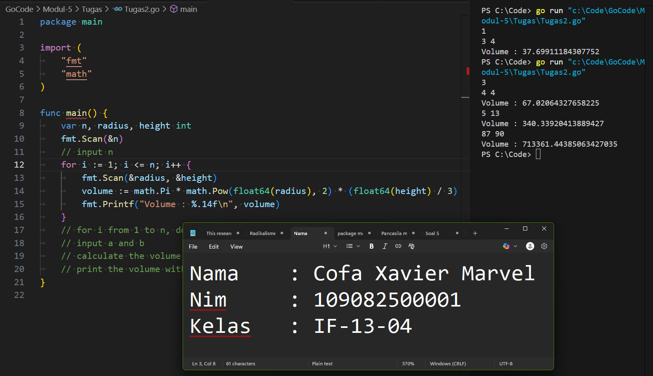

Deskripsi program

This program calculates the volume a number of a cones.

n, radius, and height are ints

n being the number of cones and the two numbers proceeding it is the radius and the height of the cone.

It calculates it by using the math library to allow the use of math.Pi and math.Pow, and casting to set the variables radius and height as float64.

Tugas3

Source code

package main

import (

    "fmt"

)

func main() {

    var x, n int

    // declare x and n as int

    fmt.Scan(&x, &n)

    // input n

    for i := 0; i <= n; i++ {

        x = x + x

    }

    // for i from 1 to n, do the following:

    // add x to x

    // increment i by 1

    fmt.Print(x)

}

Screenshoot program

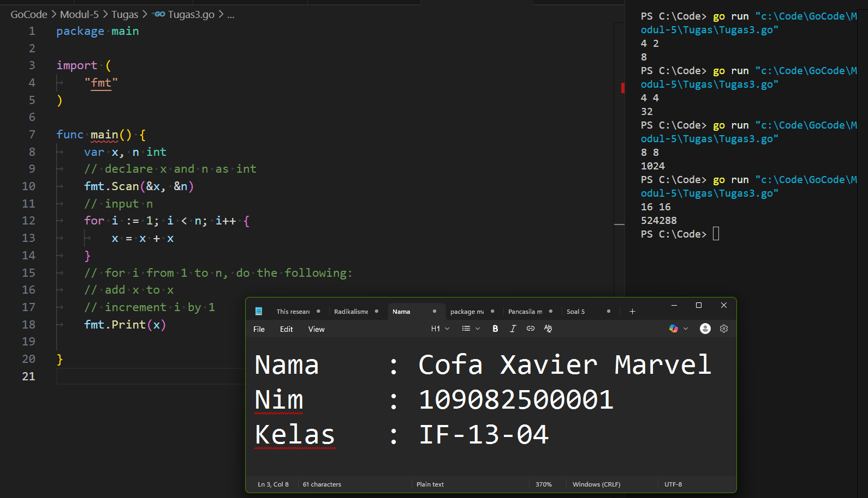

Deskripsi program

This program mimics the function of multiplication by adding x to x until I is equal to n.

Tugas3

Source code

package main

import "fmt"

func main() {

    var x int

    fmt.Scan(&x)

    // declare x as int

    // input x

    for i := x - 1; i >= 1; i-- {

        x = x * i

    }

    // for i from x-1 to 1, do the following:

    // decrement i by 1

    // multiply x by i

    // until i is less than 1

    fmt.Print(x)

}

Screenshoot program

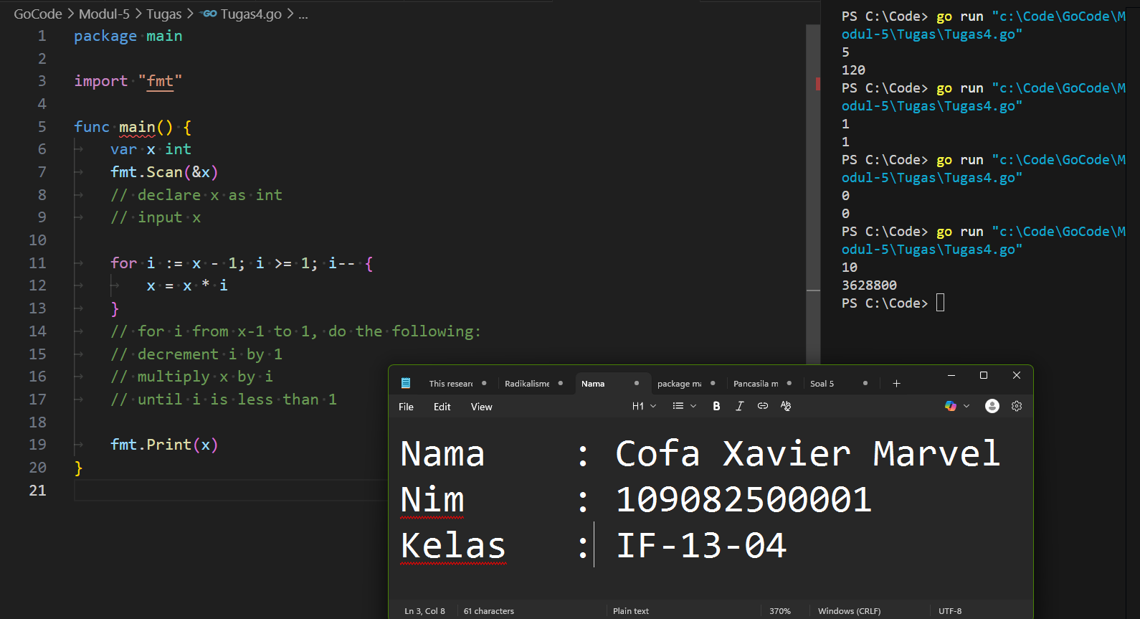

Deskripsi program

This program mimics the function of factorials by, in a for loop, multiplying x and I together whilst decreasing I till it is equal to 1. And printing x out side of the for loop.